**Unit: Aerosols and Climate Change**

**Activity:** Physical Properties and Chemistry of Solid Aerosols

**Introduction**

The purpose of this activity is to become familiar with some of the physical and chemical properties of the most common aerosols. Examining the various physical properties of different types of aerosols can help gain a better understanding of how these become suspended in the troposphere and how they react in the presence of water vapor and radiation.

**Background**

Aerosols individual chemical characteristics define how these particles interact with water vapor and radiation in the lower atmosphere. Aerosols are essential to the formation of clouds. In order for clouds to form the tiny water vapor droplets need a surface to attach to. The minute specs of aerosols suspended in the lower atmosphere provide such a surface. Once the water vapor attaches it will change from its gas form to liquid water. Aerosols provide a surface where microscopic water vapor droplets can attach and change into liquid through the physical process of condensation. The aerosols involved in the process of cloud formation are called cloud condensation nuclei (CCN). In addition of the presence of CCN’s for clouds the form condensation also needs to occur. This happens when water vapor meets cooler air throughout the earth’s troposphere.

**Materials:**

Volcanic ash

Sulfur

Salt

Dirt

Pulverized Charcoal

Petri dish for each aerosol

Magnifiers (a few per group)

Microscope slides

Microscope covers

Measuring spoon

Goggles

Gloves

Several toothpicks

Clear tape or hot glue

**Optional Materials:**

Magnifier boxes

Compound or dissecting microscope or both

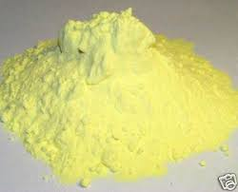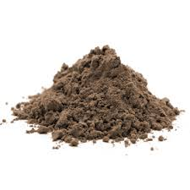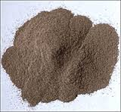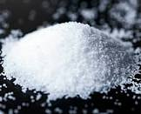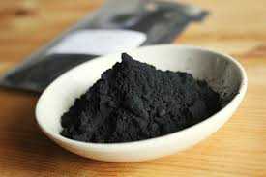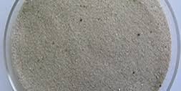

**Sulfur Dirt Volcanic Ash Salt Charcoal Sand**

**Preparation:**

1. Sulfur and volcanic ash can be purchased from science supply stores, see list of suppliers below.
2. Divide students into small groups. Each group should have a set of six petri dishes filled with the different aerosols.
3. Use a petri dish per powder. Fill each petri dish with the same amount, approximately two to three tablespoons should suffice. Seal each petri dish to avoid spilling. Label the petri dishes 1 through 6. Make sure the label or marker print does not interfere with viewing the powder through the petri dish.
4. Make an additional set of petri dishes without sealing. Keep these under your control. They will be used for tactile inspection and for slide preparation.
5. Before distributing the materials discuss safety with the students about how to manipulate chemicals and the importance of keeping goggles and gloves on.
6. Students will record their observations using the chart provided. This chart can be modified or designed by the students themselves.
7. Prepare a station with the dissecting scope if you have one or microscope. Have them sprinkle a little amount on a slide and place cover slip.

**Procedure:**

1. Before distributing the materials initiate a conversation among the students asking them what type of information they think they should collect as they observe the physical properties of various solid chemicals. **Do not tell them what they are.** Through this activity they are going to try to decipher what they are through recording the different physical properties. Let them know what they will be doing this with out telling them what are the chemicals.
2. Ask the students to make a list of general categories. You can also challenge them by asking them to think how would they go about organizing their observations.
3. Log each group’s list without discussing them. Make sure that each list remains intact **don’t eliminate** repeating categories. Once all lists are on the board search for those categories the groups have in common and begin a new list with those items and add the rest of categories to the list. This discussion is optional but is a great opportunity to generate conversations that help validate students ideas and knowledge as well a get them to focus on how to collect data on their observations.
4. Distribute the data observation sheet, one per student. Or generate one or modify the data sheet provided based on the student’s input.

1. Distribute the chemicals to each group and encourage students to discuss the physical properties of the chemicals.
2. Once students have thoroughly examined the chemicals invite them to touch them with gloves on.
3. Invite them to examine the powders under the microscope. You can use a dissecting scope or a compound microscope or both. Ask them to pay close attention of how the powders react with the light, how do they look under the microscope.
4. Once they are done making their observations have each group report on their findings. Have students record their microscope observations in the column labeled observations. Alternative if you don’t any time of microscope you can place the powders under a light source and observe the chemical with the naked eye.

**Discussion**

After each group has reported their list of observations you can now reveal the origin of the chemicals. Follow up by asking them probing questions that will further the investigation and reveal the natural sources of these chemicals.

**Questions:**

1. Where are these found in nature in addition to their natural source?
2. Where can we find them in the environment?
3. How can these disperse?

**Vocabulary:**

*Aerosols* - Are tiny liquid and solid particles suspended in the troposphere and stratosphere. They are various sources of aerosols some occur naturally and others because human activity that causes pollution.

*Cloud Condensation Nuclei (CNN)* – Also known as cloud seeds are tiny specs about 0.2μm approximately a 1/100th of the size of a cloud water vapor droplet in which the water vapor attaches to so that it can undergo a phase change from gas to liquid in other words condensate.

*Condensation* – When a gas such as water vapor cools down and undergoes a phase change from gas to liquid.

*Dirt* – Is made of off soil, which has different consistency depending on the geology and living organisms of the region. Dirt or soil is made up of organic materials, clay and rock sediments.

*Sand –* Is weathered and eroded rock.

*Charcoal* – Is a form of carbon produced from organic matter such as wood and bone that has been heated without air.

*Salt* – Is a mineral composed of sodium chloride. Salt is dissolved in the worlds oceans and its’ what give the water it’s taste.

*Sand* – Its’ made of small grains of rock that have been eroded or weathered over time.

*Sulfur* – Is a yellow nonmetallic element, which is a crystalline solid. It is used to make matches and gives out and odor when it is burned. It is naturally found around areas of hot springs and volcanic regions.

**Suppliers:**

Volcanic Ash:

American Educational Products

<https://www.amep.com/index.php?route=product/search&search=volcanic%20ash>

Sulfur:

Duda Energy, LLC. – Biodiesel Supply

Tel. (855)-DUDA-BIO (1-855-383-2246)

<http://www.dudadiesel.com/choose_item.php?id=sulfur1&gclid=Cj0KEQjwxLC9BRDb1dP8o7Op68IBEiQAwWggQKrEnBmTv9pQmyX8CvXQjK1xeolctlRbPu_Ki6jkjVIaAlzz8P8HAQ>

Amazon.com

Charcoal:

Can be purchased at pet stores in powder form as activated carbon used for filters or a crushed piece of BBQ charcoal will work as well.

**Unit: Aerosols and Climate Change Name: _______________________________**

**Activity:** Physical Properties and  **Date: _______________________________**

Chemistry of Solid Aerosols

|  |  |  |  |  |  |
| --- | --- | --- | --- | --- | --- |
| **Physical Properties Data Chart** | | | | | |
| **Chemical #** | **Color** | **Grain Size** | **Texture** | **Luster** | **Observations** |
|  |  |  |  |  |  |
|  |  |  |  |  |  |
|  |  |  |  |  |  |
|  |  |  |  |  |  |
|  |  |  |  |  |  |
|  |  |  |  |  |  |

**Suggestions of how to fill the columns:**

|  |  |
| --- | --- |
| **Grain Size** | To describe the grain size you can use a scale 1 to 6. 1 for the smallest grains and 6 for the largest. The size is relative to each other. |
| **Texture** | Fine, Gritty, Rough |
| **Luster** | Opaque, Shiny, and Mat. You can use other words that best help describe how it reflects or doesn’t reflect light. |
| **Observations** | Use to describe how it moves, more refined details of how it looks. |